Name____________________________________________________________ Date_____________________ Per_____

**Homework Week #2 Due: September 12, 2016**

**Triangle Similarity**

|  |  |
| --- | --- |
| Assuming the two triangles are similar, find the tower's height from the given measurements below.  https://w3apps.ednet.ns.ca/itembank/GetImage.asp?ID=ItemBank_3099_1.png | Tonya is 1.3 meters tall. She stands 7 meters in front of a tree and casts a shadow 1.8 meters long. How tall is the tree?  https://w3apps.ednet.ns.ca/itembank/GetImage.asp?ID=ItemBank_3111_1.png |
| State whether or not the following triangles are similar and support your answer.  https://w3apps.ednet.ns.ca/itembank/GetImage.asp?ID=ItemBank_3114_1.png | Stephanie casts a shadow of 1.2 m and she is 1.8 m tall. A wind turbine casts a shadow of 10 m at the same time that Stephanie measured her shadow. Draw a diagram of this situation and then calculate how tall the wind turbine is. |

**Triangle Congruence**

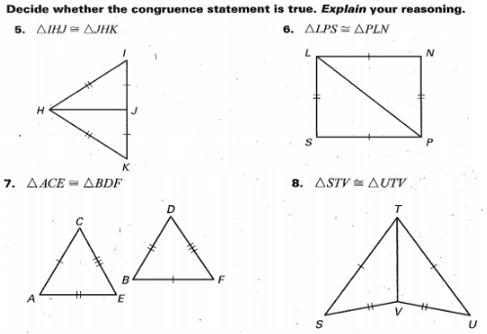

**Centers of Triangles**

Point *G* is the centroid of ∆ *ABC.* Use the given information to find the value of the variable*.*

|  |  |  |
| --- | --- | --- |
|  | 9. FG = x + 8 and GA = 6x – 4  x = __________ | 10. If CG = 3y + 7 and CE = 6y  y = __________ |

**Volume**

Use your knowledge of volume to complete each problem. Round each answer to the nearest hundredth unless otherwise indicated.

1. A cone has a height of 2 feet and a radius of 1 foot. What is its volume?
2. A cylinder has a height of 6 cm and a circumference of 10 cm. What is the volume of the cylinder?
3. A cone and a cylinder are the same height. How will their radii differ if their volumes are the same?
4. A cylindrical swimming pool has a circumference of 125 feet. The water in the pool is 5 feet deep. What is the volume of the pool? How many hours will it take to fill the pool with water? Assume the water flow is 5 gallons per minute. 1 cubic foot = 7.40852 gallons.
5. A pyramid in Giza, Egypt has a square base with side lengths of 230 meters. Its height is 146.5 meters. What is its volume?

**Density**

1. A student measures the mass of an 8 cm3 block of brown sugar to be 12.9 g. What is the density of the brown sugar?
2. A chef fills a 50 mL container with 43.5 g of cooking oil. What is the density of the oil?
3. Calculate the mass of a liquid with a density of 2.5 g/mL and a volume of 15 mL.
4. Calculate the volume of a liquid with a density of 5.45 g/mL and a mass of 65 g.
5. A machine shop worker records the mass of an aluminum cube as 176 g. If one side of the cube measures 4 cm, what is the density of the aluminum?